INTRODUCTION

  - ABOUT THE PROJECT

The Language Learning System is an advanced online educational platform developed to deliver an immersive and structured learning environment for individuals aspiring to achieve proficiency in various languages. This system integrates dynamic instructional content, periodic quizzes, and comprehensive administrative tools to facilitate an efficient and engaging learning experience for students, instructors, parents, and administrators. By offering a well-organized, user-friendly, and technologically enhanced platform, the system promotes effective language acquisition while ensuring streamlined content management, performance monitoring, and administrative oversight.
The platform is designed with a multi-user role architecture, accommodating four primary user categories—students, instructors, parents, and administrators—each with specific functionalities and privileges.
Emphasizing usability, accessibility, and inclusivity, the Language Learning System features a clean, responsive, and device-compatible interface that supports engagement across desktops, tablets, and mobile devices.
By merging traditional pedagogical principles with contemporary digital technologies, the Language Learning System establishes a comprehensive, technology-driven framework for language education. It effectively bridges the gap between conventional classroom instruction and modern e-learning, providing a sustainable, scalable, and interactive solution for linguistic proficiency development.

REQUIREMENT ANALYSIS
AND
SPECIFICATION

2.1. SYSTEM STUDY

The Language Learning System is designed to provide a comprehensive, structured, and engaging approach to the acquisition of multiple languages through a technology-enhanced learning environment. The system employs a role-based access architecture that accommodates four key user groups — students, instructors, parents, and administrators — ensuring smooth interaction and functionality across all levels.
Students can access a wide range of lessons, complete interactive assignments and quizzes, and track their learning progress through continuous assessments and performance analytics. Instructors are responsible for creating and managing course materials, evaluating assignments, conducting quizzes, and providing individualized feedback to students. Parents are integrated into the system to monitor their child’s learning activities, quiz results, attendance records, and progress reports, thereby promoting active involvement in the educational process. Administrators oversee the management of user accounts, content approval, and system maintenance to ensure operational stability, data security, and accessibility.
By consolidating all instructional and administrative tools into a unified digital framework, the system minimizes reliance on external applications and resources. Its responsive and intuitive interface ensures consistent accessibility across multiple devices, including desktops, tablets, and mobile phones, thereby facilitating flexible and uninterrupted learning.
The Language Learning System represents a centralized and scalable platform that effectively integrates instructional delivery, assessment, and performance monitoring. It serves both individual learners and educational institutions, supporting a modern, interactive, and efficient language learning experience.
The primary components involved in the development of this software include:

- Requirement Analysis and System Design
- Implementation
- Testing
- System Maintenance and Documentation

2.1.1. EXISTING SYSTEM

The existing approach to language education management remains largely manual, fragmented, and unstructured, particularly in institutions that rely on traditional methods of teaching and administration. Different tools are often employed for isolated purposes—such as spreadsheets for maintaining student data, emails for assignment distribution, and manual grading for performance evaluation. This lack of integration results in inefficient workflows, increased administrative overhead, and a higher likelihood of human error.
The decentralized nature of these tools often leads to delayed feedback, inconsistent access to learning materials, and difficulty in tracking student performance over time. Teachers frequently face challenges in monitoring student engagement and progress due to the absence of real-time data and analytics. Furthermore, manual processes for registration, attendance tracking, and payment management are time-consuming, error-prone, and difficult to scale.
Students in traditional systems encounter several issues, such as limited accessibility to updated resources, unclear assignment submission procedures, and delays in receiving evaluation results. The lack of an automated feedback mechanism diminishes opportunities for timely academic improvement. In addition, parental involvement is often minimal, as there are no structured means for parents to track student progress or communicate effectively with instructors.
Administrators face similar challenges in ensuring uniform course delivery, managing user data, and evaluating teaching outcomes. The absence of a centralized and automated platform restricts their ability to maintain system-wide transparency and efficiency.
Overall, the current system suffers from a lack of integration, automation, and real-time monitoring capabilities, which hampers effective communication among students, instructors, parents, and administrators. These shortcomings underscore the urgent need for a comprehensive digital solution—such as the proposed Language Learning System—to streamline educational management, enhance accessibility, and foster a more efficient and collaborative learning environment.

2.1.2. PROPOSED SYSTEM

The proposed Language Learning System is designed to streamline, automate, and modernize the management of language education, effectively addressing the inefficiencies associated with the existing manual and fragmented methods. This integrated digital platform aims to centralize all academic and administrative functions — from student registration and course management to evaluation, parental tracking, and progress monitoring — into a unified and accessible environment.
The system will consolidate all essential tools within a single, centralized framework, eliminating the dependence on multiple disconnected applications such as spreadsheets, emails, and offline grading methods. By implementing role-based access control, the platform will support distinct functionalities for students, instructors, parents, and administrators, ensuring security, efficiency, and clarity in all interactions.

2.1.3. FEASIBILITY STUDY

The feasibility study evaluates whether the Language Learning System is practical and viable to develop. It covers technical, economic, and operational aspects.Technical feasibility confirms that technologies such as React, Flask, and MySQL are suitable and readily available. React ensures a dynamic and responsive user interface, while Flask provides a lightweight and efficient backend framework.Economic feasibility shows that using open-source technologies and low-cost cloud hosting makes the system highly cost-effective and sustainable for long-term use.Operational feasibility ensures that the platform is user-friendly for students, instructors, parents, and administrators, requiring minimal training and offering seamless access across devices. Overall, the project is achievable, scalable, and beneficial, providing a sustainable digital solution for language education.

2.1.3.1. TECHNICAL FEASIBILITY

The technical feasibility analysis confirms that the technologies required for the development of the Language Learning System are readily available, reliable, and suitable for implementation. The system will be developed using React for the front-end interface and Flask for the back-end framework. React provides a responsive, dynamic, and user-friendly interface that enhances accessibility across multiple devices, while Flask offers a lightweight yet powerful Python-based backend capable of handling data processing, authentication, and API integration efficiently.

2.1.3.2. ECONOMICAL FEASIBILITY

The system is highly economical because all tools and platforms used are free and open-source. Hosting costs are minimal for a small to mid-sized platform. The operational savings gained through automation outweigh the initial development efforts. Additionally, the system reduces the need for manual tracking, which lowers long-term administrative costs.

2.1.3.3. OPERATIONAL FEASIBILITY

The operational feasibility assessment verifies that the system is practical and user-friendly for all intended users, including students, instructors, parents, and administrators. The platform’s interface will be intuitive, requiring minimal technical expertise or training to operate. Features such as automated assessments, quiz management, progress tracking, and communication tools will simplify day-to-day operations and improve the learning experience.

2.2. USER CHARACTERISTICS

The Language Learning System is designed to provide users with a simple, efficient, and organized platform for managing learning and administrative activities with minimal complexity. The system ensures smooth operation, accessibility, and effective interaction among all users. It supports four main types of users:
- Administrator
- Instructor
- Student
- Parent

2.2.1 Administrator

The Administrator manages and supervises all activities within the system. Their responsibilities include user account management, course creation, content approval, and system monitoring. Administrators ensure the smooth operation, data security, and overall functionality of the platform, maintaining an organized and efficient learning environment.

2.2.2 Students

Students use the platform to access learning materials, complete quizzes and assignments, view progress reports, and participate in evaluations. The interface is intuitive and user-friendly, allowing learners to easily navigate lessons, track performance, and enhance their language proficiency at their own pace.

2.2.3 Staff

Staff members are responsible for creating, managing, and updating course materials, reviewing student submissions, assigning grades, and providing personalized feedback. They play a key role in ensuring academic quality and monitoring learner performance.

2.2.4 Parents

Parents have access to their child’s learning records, including quiz results, and progress reports. They can monitor performance and communicate with instructors, ensuring active participation in the student’s academic progress.

2.3. SYSTEM SPECIFICATION

2.3.1. Hardware Specification
The selection of hardware is very important in the existence and proper working of any software. When selecting the hardware, the size and capacity requirements are also important. Below is some of the hardware that is required by the system.

Processor | Intel Core i3 or higher
RAM | Minimum 4 GB
Hard Disk | 128 GB And Above
Key Board | Normal or Multimedia
Monitor | 15” CRT or LCD monitor
Mouse | Compatible Mouse

2.3.2 Software Specifications

Operating System | Windows / Linux / macOS
Front End
  React.js
Back End | Flask (Python Framework)
Database | MySQL

2.3.3 ABOUT SOFTWARE TOOLS

Selecting the appropriate software tools is essential to ensure that the system functions efficiently, remains scalable, and supports future enhancements. The following software tools are utilized in the development of the Language Learning System:
- React.js
- Flask (Python Framework)
- MySQL

React.js

React.js is an open-source JavaScript library developed by Facebook, primarily used for building dynamic, responsive, and high-performance user interfaces. It allows developers to create reusable UI components that enhance maintainability and efficiency. React’s virtual DOM significantly improves rendering speed and user experience, making it ideal for interactive web-based learning platforms.
React also supports real-time data updates and component-based architecture, which enables smooth integration with backend services such as Flask. Its flexibility allows the system to be responsive across various devices, ensuring a consistent user experience for students, instructors, parents, and administrators.

Flask

Flask is a lightweight and flexible Python-based web framework used for backend development. It provides powerful tools and libraries for creating secure, scalable, and maintainable web applications. Flask follows a modular design pattern, allowing developers to add functionalities as required while maintaining simplicity and performance.In the Language Learning System, Flask handles essential backend operations such as user authentication, data management, quiz processing, progress tracking, and communication between the front end (React)

and the database (MySQL). Its integration with modern APIs ena bles real-time data exchange and ensures smooth interaction among system components.

MySQL

MySQL is an open-source Relational Database Management System (RDBMS) widely used for secure, reliable, and efficient data storage. It manages user information, course data, assignments, and assessment results within the Language Learning System.
MySQL’s robust architecture ensures data consistency, high performance, and scalability. Its ability to handle large datasets and concurrent transactions makes it well-suited for multi-user educational environments.

SYSTEM MODELING

3.1. MODULES AND DESCRIPTION

The Language Learning System is a comprehensive online platform designed to support effective and structured language education. It integrates interactive learning tools, course administration, performance tracking, and communication features to deliver a seamless experience for students, instructors, parents, and administrators.
The system is divided into 15 major modules, each responsible for specific functional areas that collectively ensure the efficient operation of the platform.
They are:

3.1.1: Academic Year Management
3.1.2: Program Management
3.1.3: Course Management
3.1.4: Staff Management
3.1.5: Study Material Management
3.1.6: Assignment Management
3.1.7: MCQ Management
3.1.8: Student Registration
3.1.9: Payment Management
3.1.10: Assignment Submission Management
3.1.11: Assignment Evaluation Management
3.1.12: Result Management
3.1.13: Communication Management
3.1.14: Certificate Management
3.1.15: Feedback Management

3.1.1: Academic Year Management
This module allows administrators to define, organize, and manage academic years, including start/end dates and active year settings.

3.1.2: Program Management
This module enables management of language programs or learning tracks, including program titles, levels, duration, and structure.

3.1.3: Course Management
This module enables administrators to create, update, and manage course information, including course titles, proficiency levels, duration, and fee structures.

3.1.4: Staff Management
This module allows administrators to register, assign, and manage staff profiles.

3.1.5: Study Material Management
This module provides tools to upload, organize, and distribute study materials such as PDFs, audio files, videos, and worksheets to students.

3.1.6: Assignment Management
This module enables administrators and instructors to create, schedule, and manage written assignments and associated instructions.

3.1.7: MCQ Management
This module allows creation and management of multiple-choice question banks, quizzes, and automated scoring configurations.

3.1.8: Student Registration
This module facilitates student enrollment, profile creation, course selection, and verification processes.

3.1.9: Payment Management
This module handles student fee records, payment tracking, invoices, receipts, and transaction history.

3.1.10: Assignment Submission Management
This module enables students to upload assignment responses and allows administrators to track submission status.

3.1.11: Assignment Evaluation Management
This module allows instructors to review submissions, assign marks, provide feedback, and record evaluation outcomes.

3.1.12: Result Management
This module compiles assessment scores, generates results, and provides students with structured performance records.

3.1.13: Communication Management
This module enables sending announcements, notifications, and updates to students and parents through integrated messaging.

3.1.14: Certificate Management
This module automatically generates completion certificates for students who successfully finish a course or program.

3.1.15: Feedback Management
This module collects, stores, and analyzes feedback from students and staff to support quality improvement.

3.2. DATA FLOW DIAGRAM

A data flow diagram is graphical tool used to describe and analyze movement of data through a system. These are central tool and the basis from which the other components are developed. The transformation of data from input to output, trough processed, may be described logically and independently of physical components associated with the system. These are known as the logical data flow movement of data between people, departments and workstations. A full description of a system actually consists of a set of data flow diagrams.

A DFD is also known as a "bubble chart" has the purpose of clarifying system requirements and identifying major transformations that will become programs in system design. So it is the starting point of the design to the lowest level of detail. A DFD consists of a series of bubbles joined by data flows in the system.

In the DFD, there are four symbols

Process that transforms data flow

Source or Destination of data

Data store

Data flow
Rules for drawing data flow diagrams

Rule 1: Establish the context of the data flow diagram by identifying all of the net input and output data flows.

Rule 2: Select a starting point for drawing the DFD.

Rule 3: Give meaningful labels to all data flow lines.

Rule 4: Label all processes with action verbs that relate input and output data flows.

Rule 5: Omit insignificant functions routinely handled in the programming process.

Rule 6: Do not include control or flow of control information.

Rule 7: Do not try to put too much information in one DFD.

Rule 8: Be prepared to start over.

Level 0 DFD Showing Language Learning System

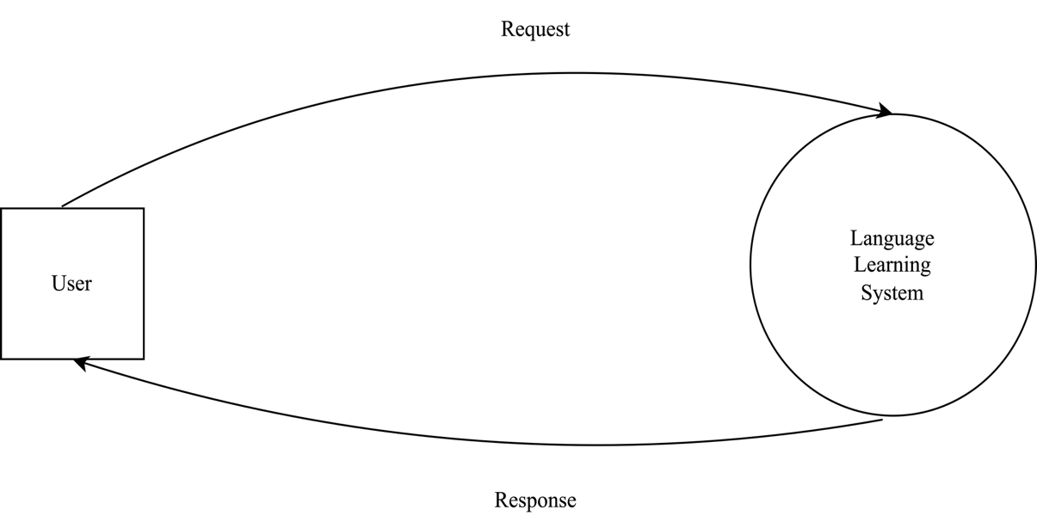

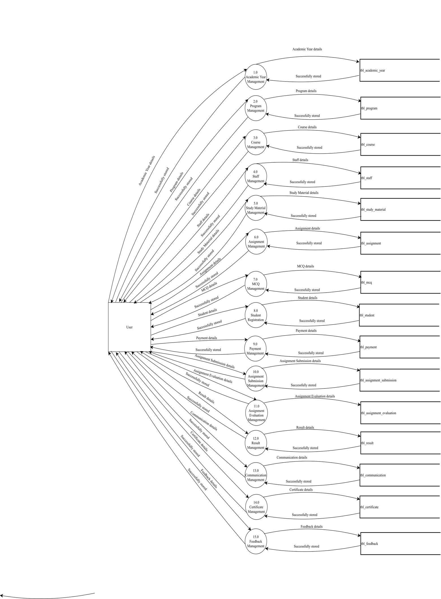
Level 1 DFD Showing Language Learning System

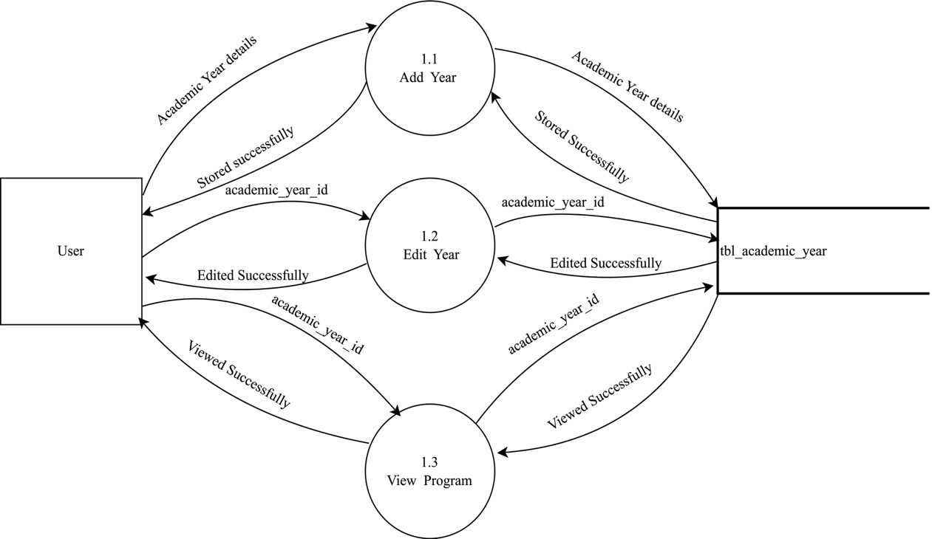
Level 2 DFD Showing Academic Year Management

Level 2 DFD Showing Program Management
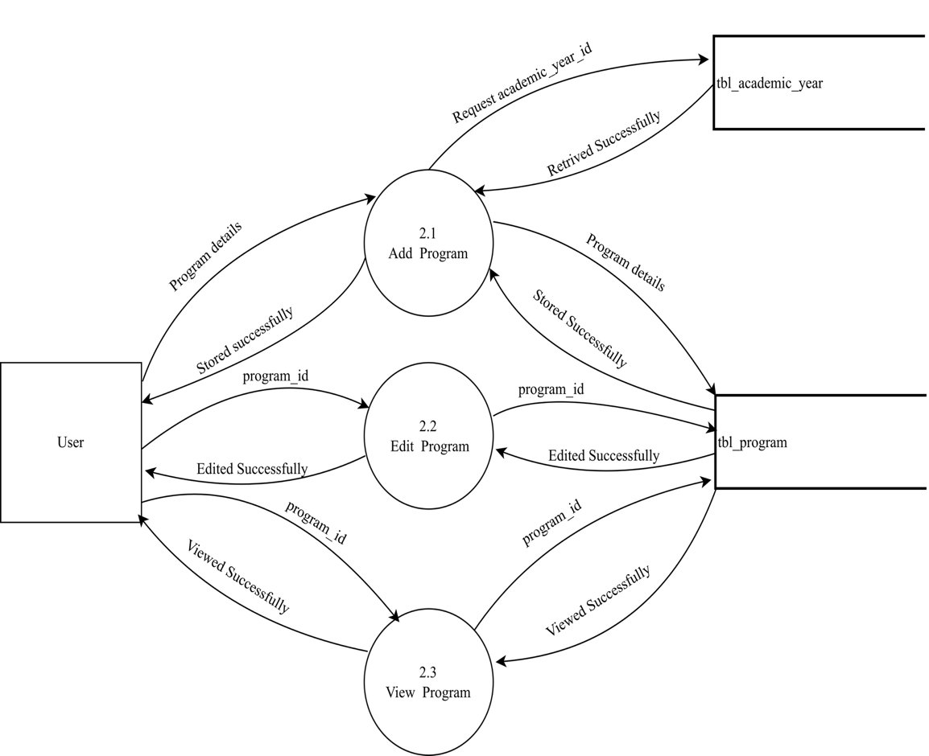

Level 2 DFD Showing Course Management
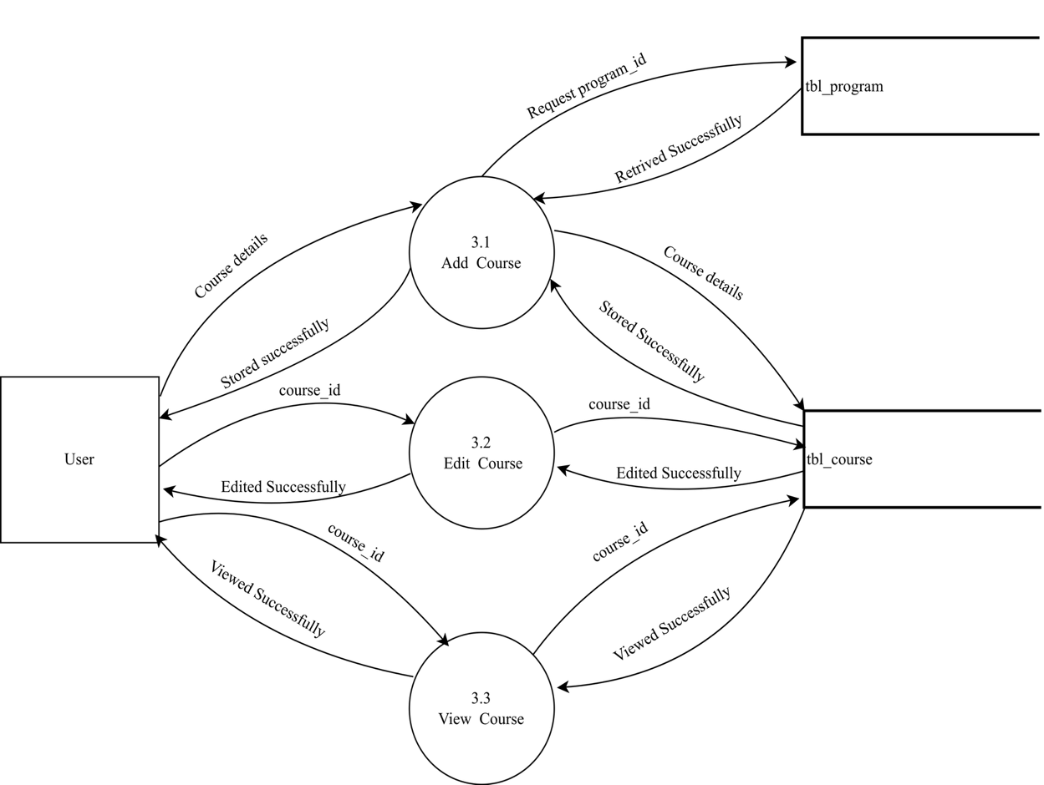

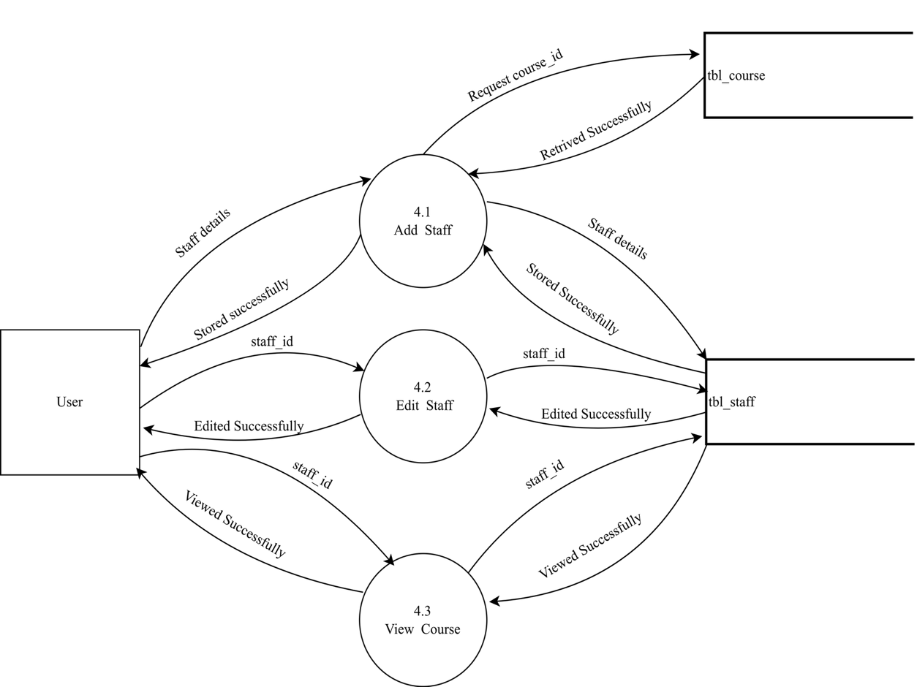
Level 2 DFD Showing Staff Management

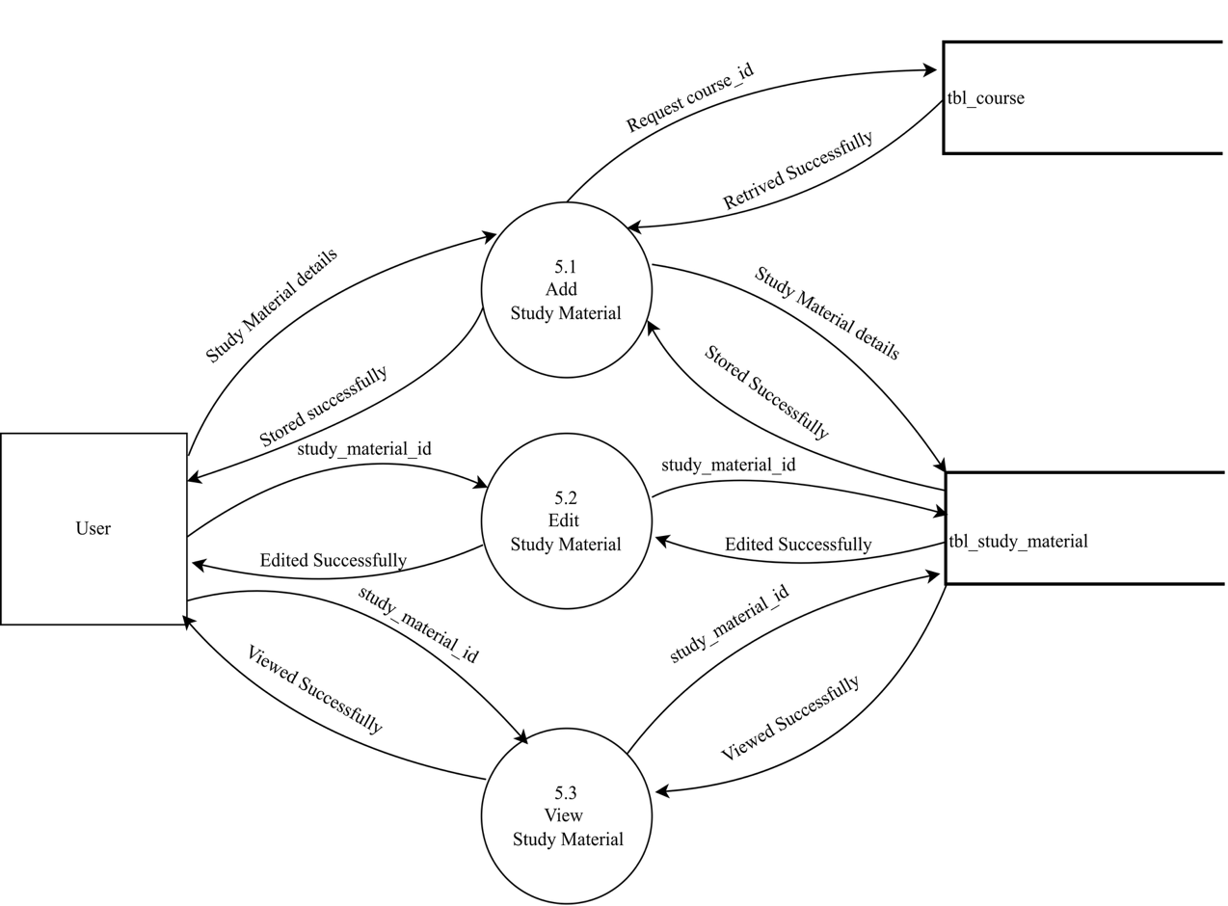
Level 2 DFD Showing Study Material Management

\

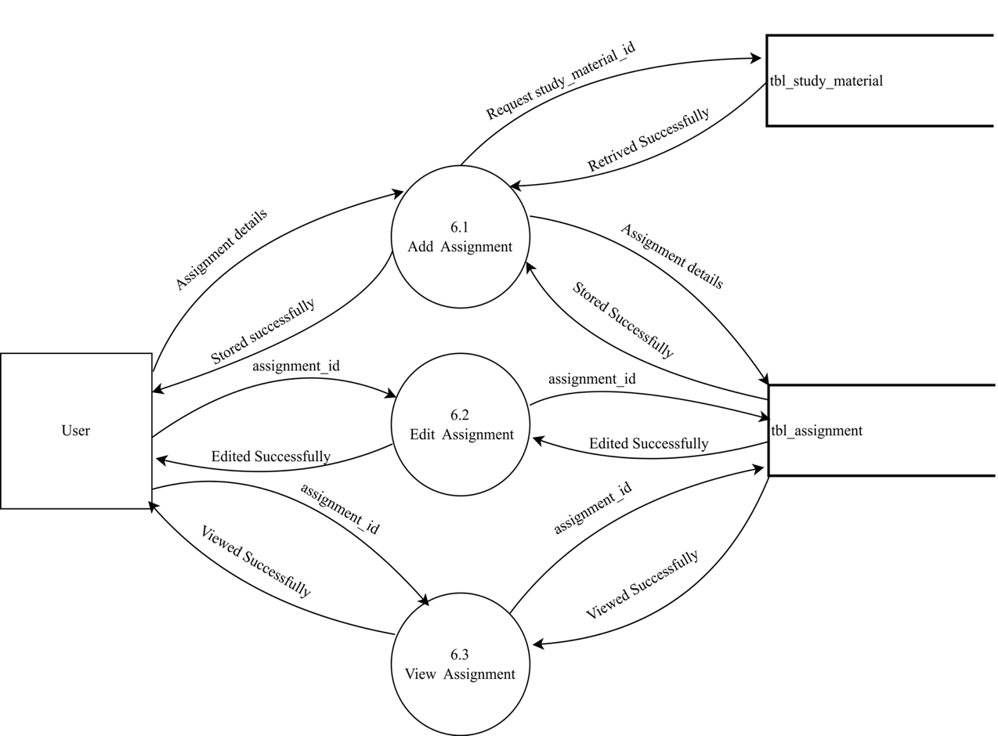
Level 2 DFD Showing Assignment Management

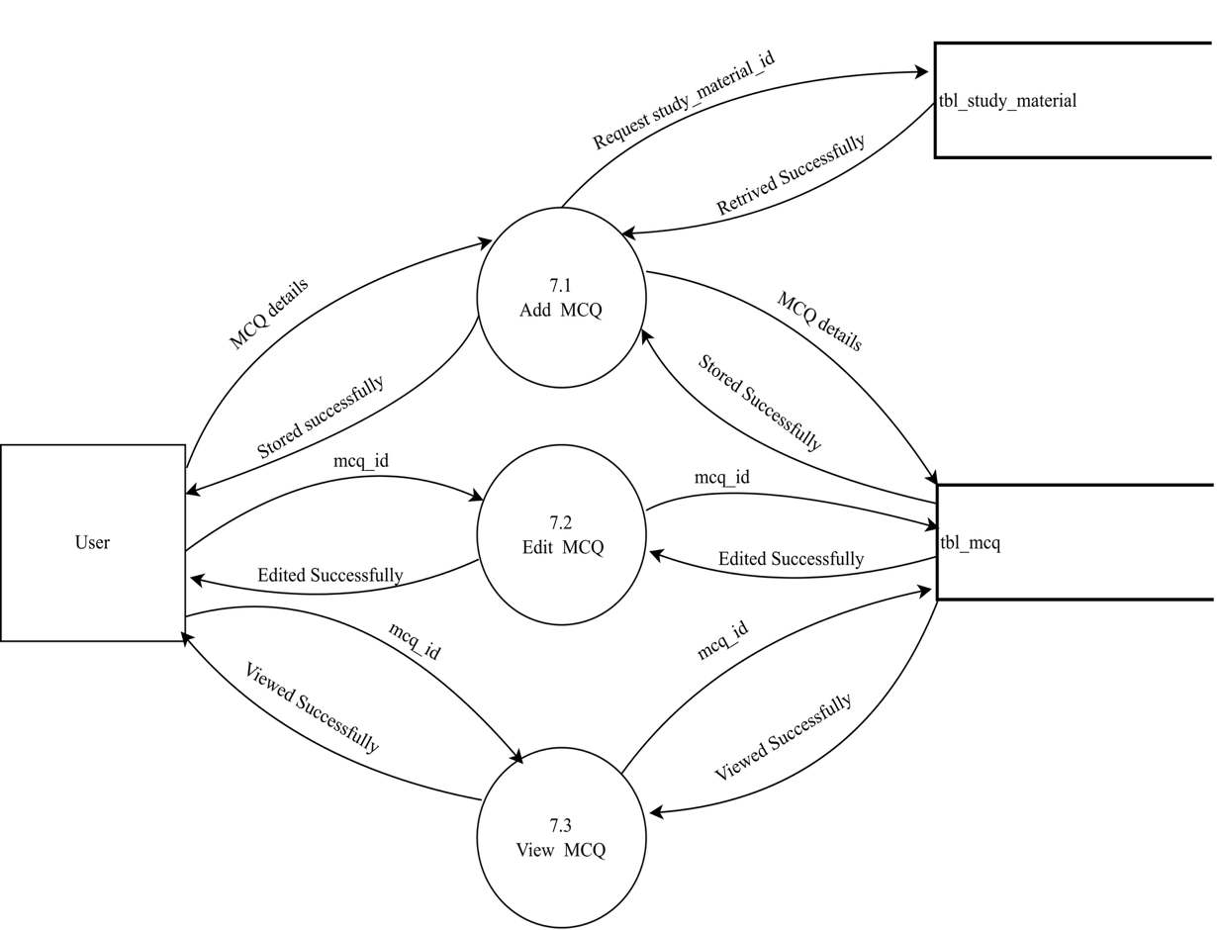
Level 2 DFD Showing MCQ Management

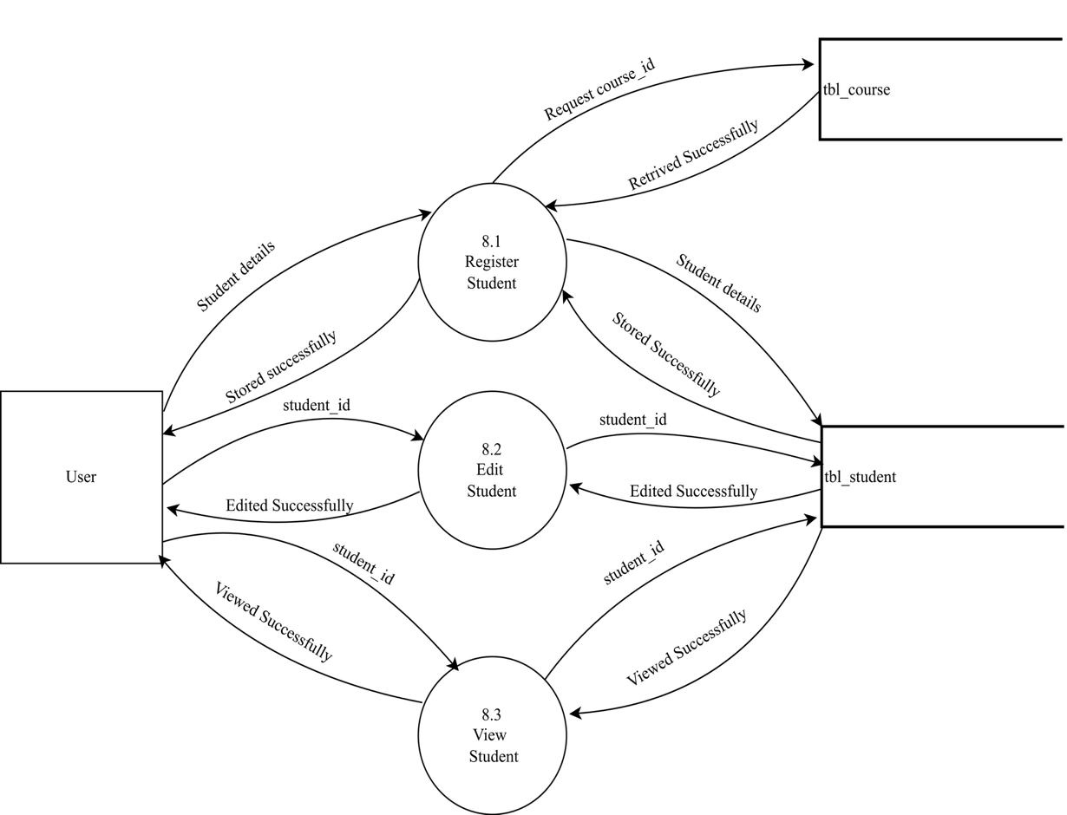
Level 2 DFD Showing Student Registration

Level 2 DFD Showing Payment Management
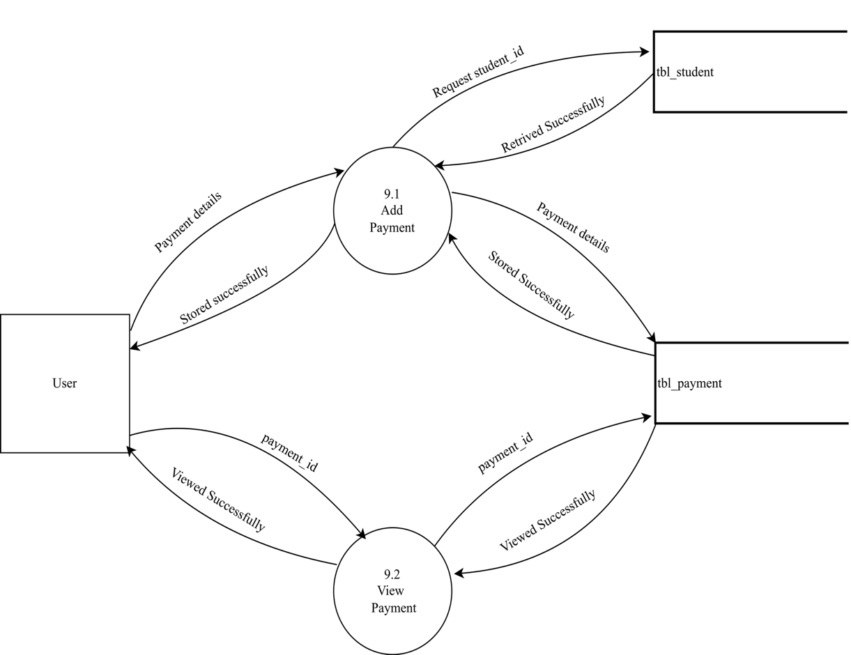

Level 2 DFD Showing Assignment Submission Management
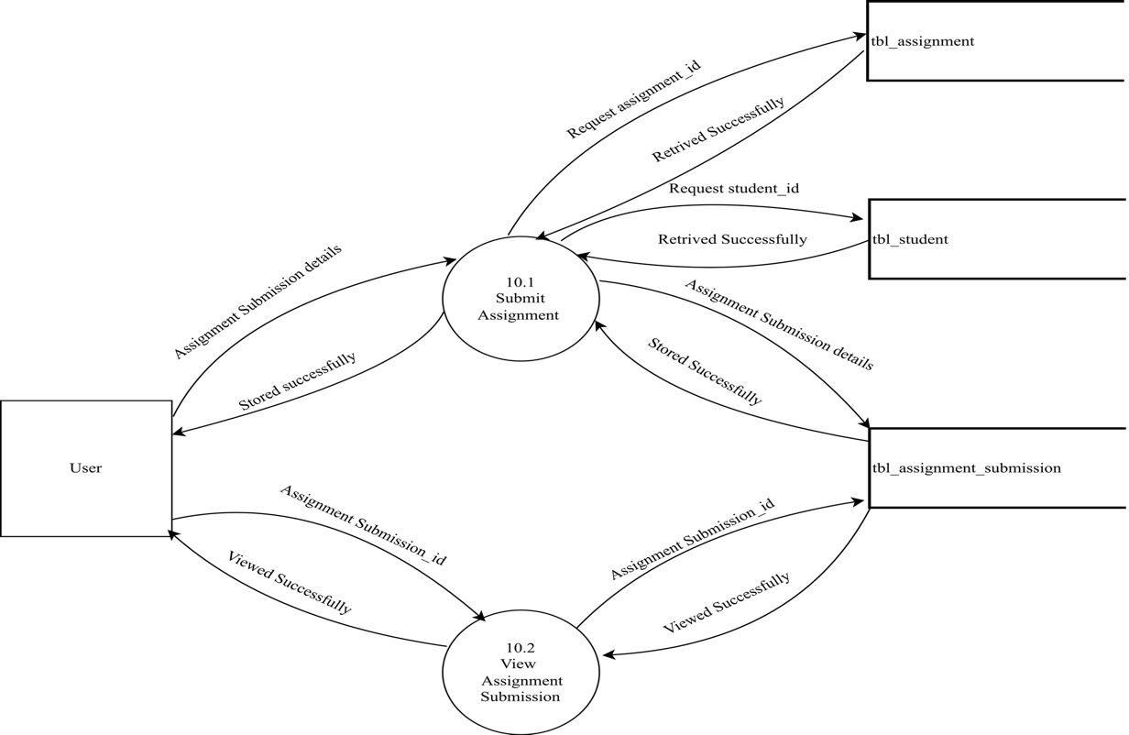

Level 2 DFD Showing Assignment Evaluation Management
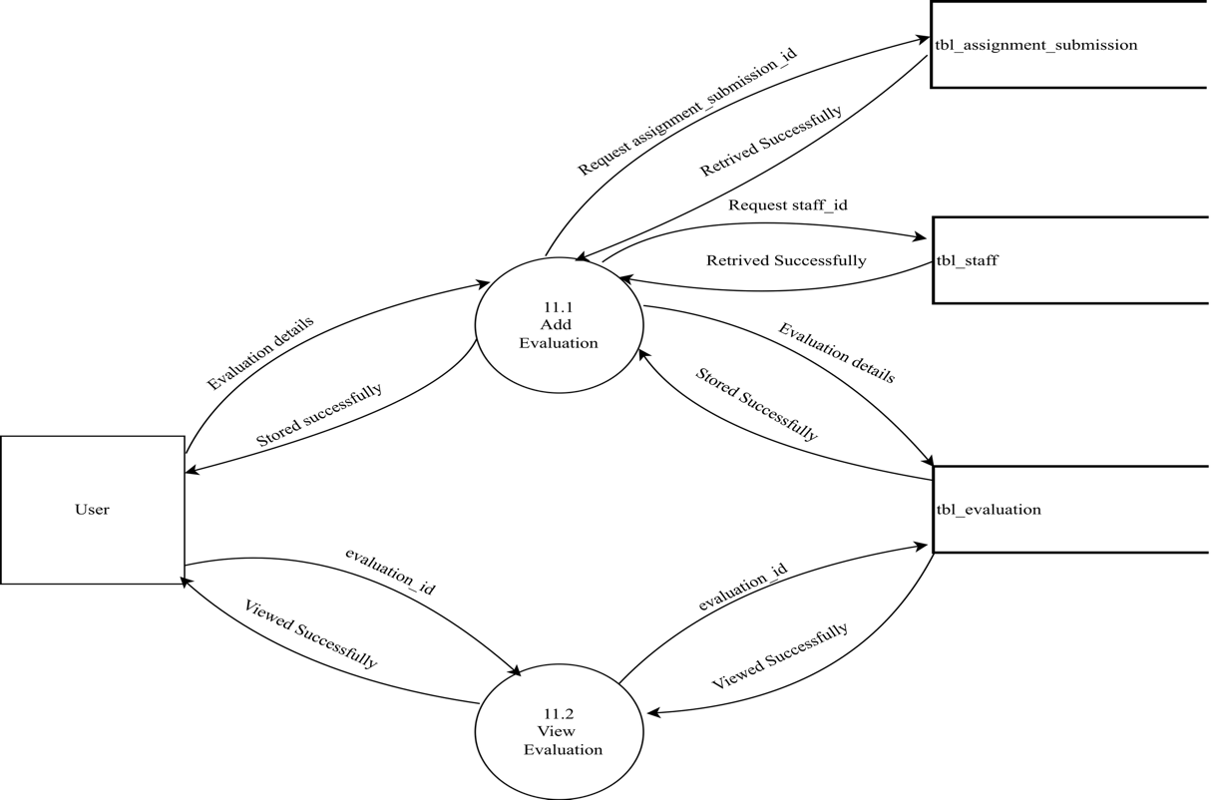

Level 2 DFD Showing Result Management
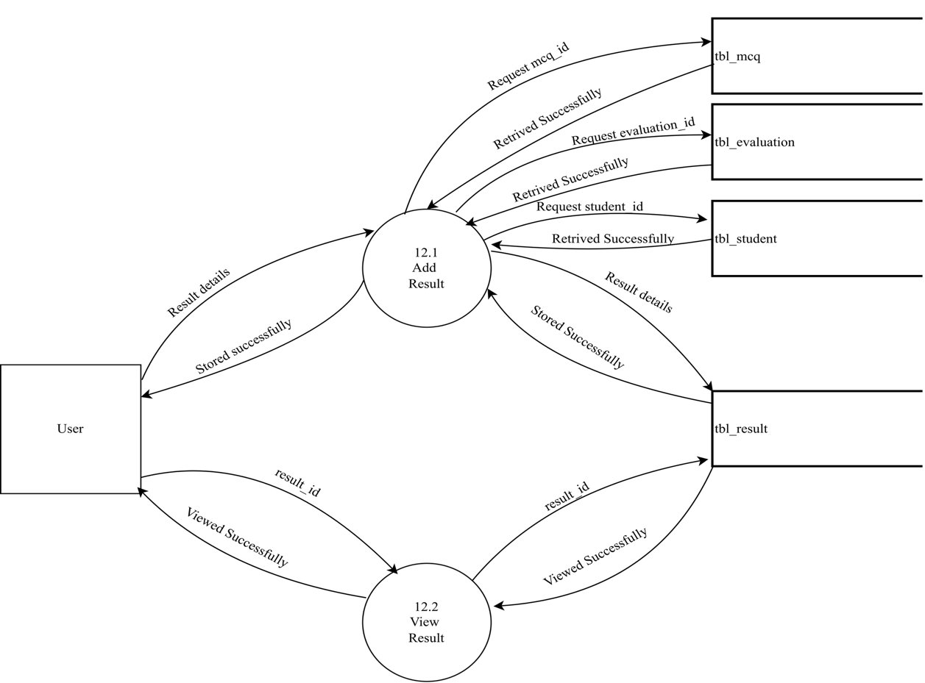

Level 2 DFD Showing Communication Management
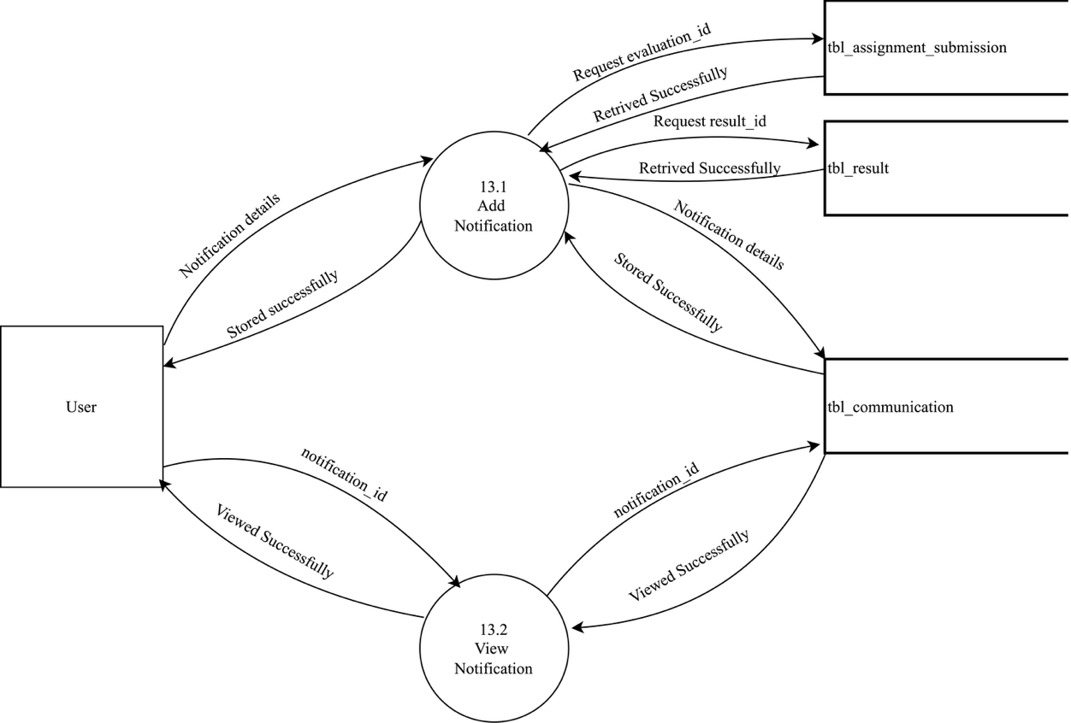

Level 2 DFD Showing Certificate Management

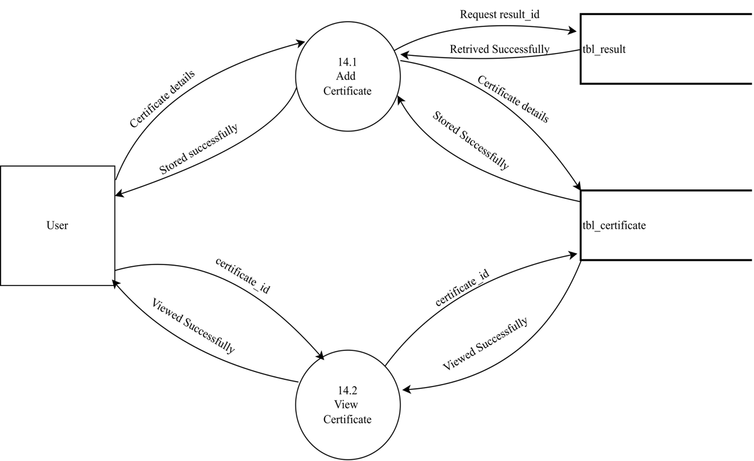

Level 2 DFD Showing Feedback Management

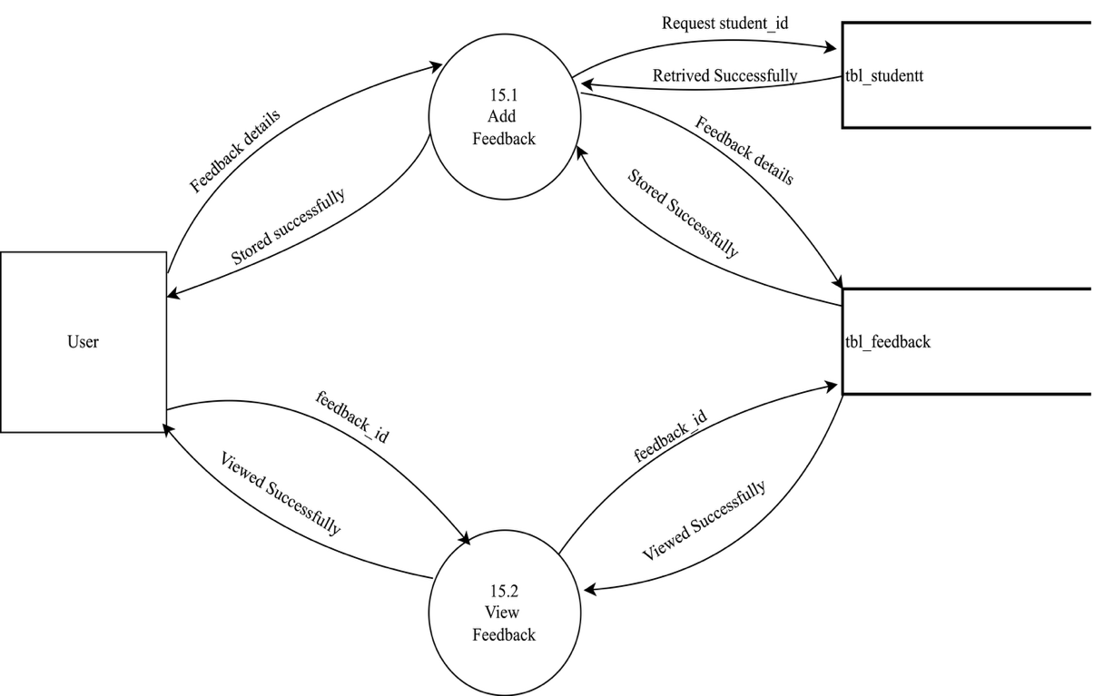

Table Design

Table: academic_year

Field | Type
academic_year_id | INT (PK)
year | VARCHAR
start_date | DATE
end_date | DATE
status | ENUM

Table: program

Field | Type
program_id | INT (PK)
program_name | VARCHAR
description | TEXT
duration_months | INT
status | ENUM

Table: course
Field | Type
course_id | INT (PK)
program_id | INT (FK)
course_name | VARCHAR
credits | INT
semester | INT
status | ENUM

Table: staff

Field | Type
staff_id | INT (PK)
name | VARCHAR
email | VARCHAR
phone | VARCHAR
qualifications | TEXT

Table: study_material

Field | Type
material_id | INT (PK)
course_id | INT (FK)
title | VARCHAR
file_path | VARCHAR
upload_date | DATE
uploaded_by | INT (FK staff)
Table: assignment

Field | Type
assignment_id | INT (PK)
material_id | INT (FK)
title | VARCHAR
instructions | TEXT
due_date | DATE

Table: mcq

Field | Type
mcq_id | INT (PK)
material_id | INT (FK)
question | TEXT
option_a | VARCHAR
option_b | VARCHAR
option_c | VARCHAR
option_d | VARCHAR
correct_option | CHAR(1)

Table: student

Field | Type
student_id | INT (PK)
name | VARCHAR
email | VARCHAR
dob | DATE
contact | VARCHAR
parent_name | VARCHAR
parent_contact | VARCHAR
parent_email | VARCHAR
course_id | INT(FK)

Table: Payment

Field | Type
payment_id | INT (PK)
student_id | INT (FK)
amount | DECIMAL
date | DATE
method | ENUM
status | ENUM

Table: assignment_submission

Field |  | Type
submission_id |  | INT (PK)
assignment_id |  | INT (FK)
 | student_id | INT (FK)
file_path |  | VARCHAR
submitted_date |  | DATE
assignemnt |  | TEXT

Table: assignment_evaluation

Field | Type
evaluation_id | INT (PK)
submission_id | INT (FK)
marks | DECIMAL
feedback | TEXT
evaluated_by | INT (FK staff)

Table: result

Field | Type
result_id | INT (PK)
student_id | INT (FK)
evaluation_id | INT (FK)
mcq_id | INT(FK)
status | ENUM
grade | VARCHAR

Table: communication

Field | Type
communication_id | INT (PK)
submission_id | INT(FK)
message | TEXT
sent_date | DATETIME
result_id | INT(FK)

Table: Certificate

Field | Type
certificate_id | INT (PK)
student_id | INT (FK)
result_id | INT (FK)
issue_date | DATE
certificate_number | VARCHAR
status | ENUM

Table: feedback

Field | Type
feedback_id | INT (PK)
student_id | INT (FK)
rating | INT
comments | TEXT
date | DATE

